E-Book Project Details.

Name: Loreal Rice
Title of your eBook: Words of Wisdom
Author/Pen Name (if used):

Copy and paste the Universal Link for your E-Book (even if it doesn't work):
https://books2read.com/u/b6E9ZW

Release Date of the book: 2027-09-28

Price of the book: $3.99

Copy and Paste your Book Description:
Words of Wisdom is a powerful collection of short stories that explore flexibility, family, and the hidden truths that shape our lives. Blending drama, mystery, and emotional realism, each story invites readers to step into the struggles and triumphs of characters as they learn to face pain, loss, and the power of self-discovery.

Copy and Paste your Short Book Description:
Words of Wisdom is a powerful collection of short stories that explore flexibility, family, and the hidden truths that shape our lives. Blending drama, mystery, and emotional realism, each story invites readers to step into the struggles and triumphs of characters as they learn to face pain, loss, and the power of self-discovery.

Which BISACS Categories (genres) did you use (in Step 1, Metadata):
FICTION / General
FICTION / Family Life / Marriage & Divorce
FICTION / Feminist
FICTION / Psychological
FICTION / Women

Copy and Paste your Descriptive Tags/Search Terms (in Step 1, Metadata):
Conflicts, Trauma, Leader, Family Drama, Female Lead

Copy and Paste your Author Bio:
Loreal D Rice is a writer and poet who uplifts others through words of wisdom and encouragement. She attends Full Sail University in pursuit of an Associate of Science in Creative Writing. Loreal’s passion for writing is the core of her identity. American Writers & Artists Institute (AWAI) is a group where she gathers inspiration. With 15 years of experience in customer service and leadership roles, she is a phoenix rising from the ashes; mistakes are the muscles that form her armor, and the words she inspires are those that never give up.

Copy and paste your website or Social Media Links:
https://lorealdrice.wordpress.com/
https://www.linkedin.com/in/loreal-rice-90926992/

Book Cover:

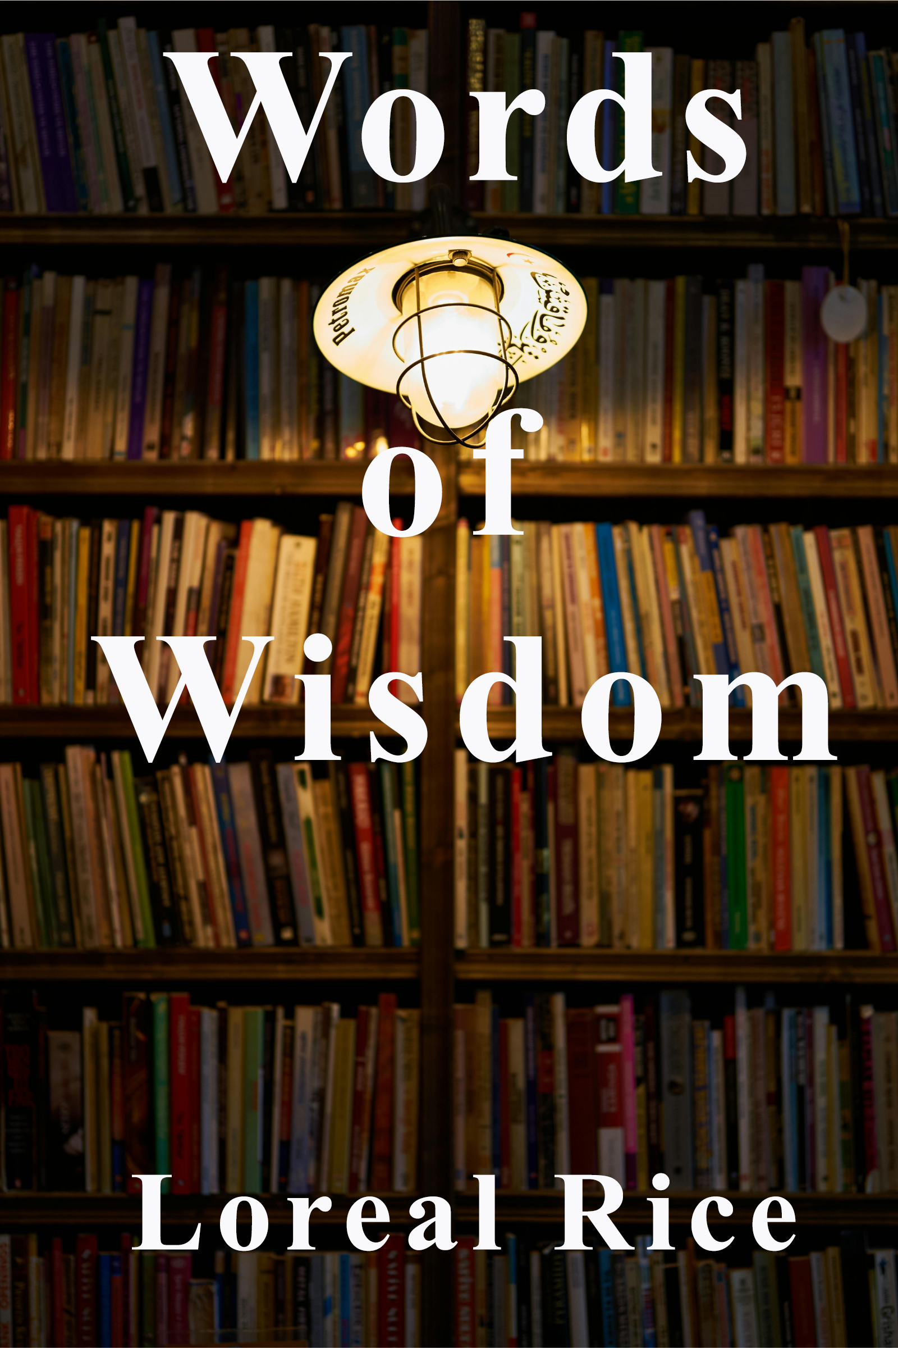

Author Photo:


Course Director's Feedback & Suggestions:
(The following items will be filled in by the Course Director, your teacher.
Not you. This is where the Course Director gives you general feedback on the things you need to do to improve your e-book.)

Course Director's Feedback & Suggestions for the:
Manuscript File Build:

Formatting of the Text:

Table of Contents:

